**Assignment- 1**

**Here I am going to share How to create an IAM user and allow access to some policies.**

1. Once you login to your AWS account you will find a search C:\Users\hp\AppData\Local\Microsoft\Windows\INetCache\IE\369B7BYW\221px-Vector_search_icon.svg[1].png box. Type IAM and click on search.

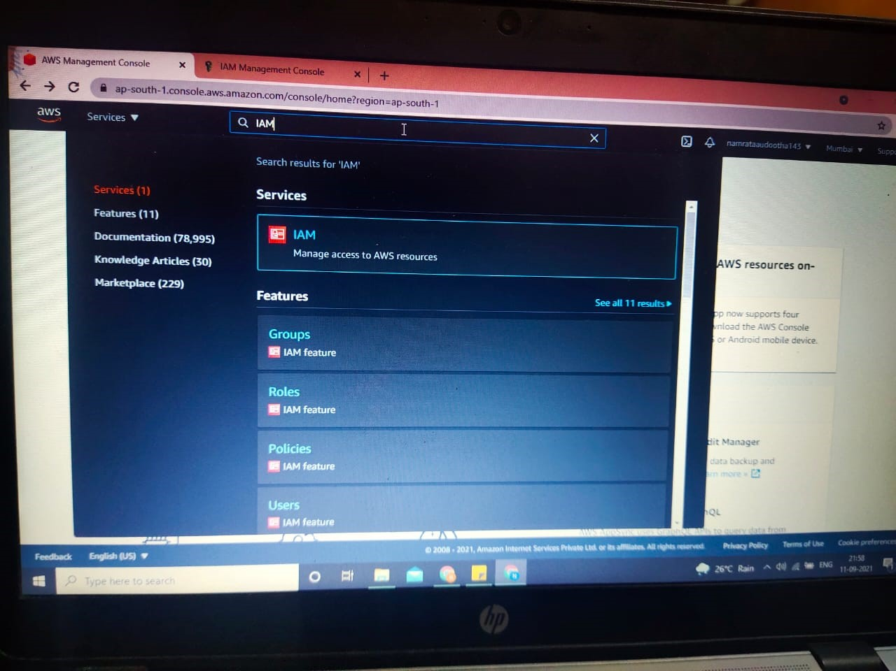

1. After opening IAM page you will see **Users** to your left side of the screen, under Access Management. Please click on Users and you will get an option to ADD users in Blue box to your right side of the screen as highlighted in the below picture.

**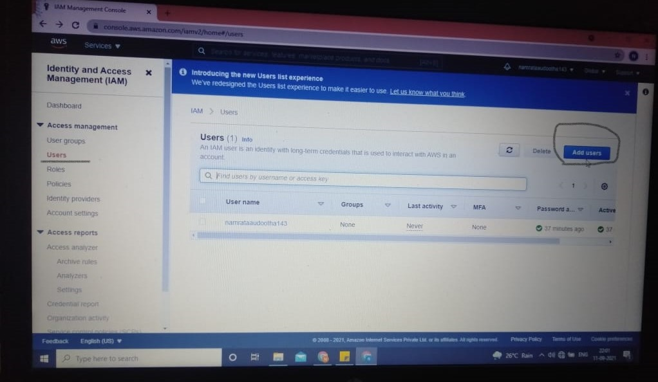**

1. After clicking on **Add users**, you will get a box to enter your User name. Add your choice of user name. Down you will see **Select AWS access type** - below there are 3 other option to be selected.

**Access type**.-You will have 2 option Programmatic access and AWS Management Console Access – You can select both the option.

Next step is **Console password** where you have 2 options to select – a. Auto generated password and b. Custom password. So here I am selecting Custom password and entering my person password.

At the end option you can allow user to reset the password at the time of sign in by selecting **Require password reset.**

After selecting all the required option, click on Next Permission displayed at the end of the screen in blue box- Refer below Picture.

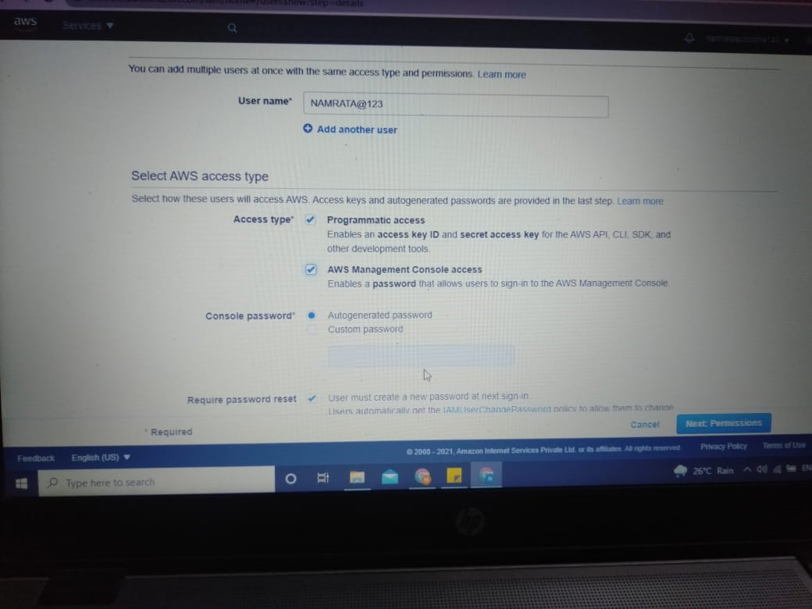

1. On the next page you will be able to give permission to user to access your policies.

Click on Attach existing policies. There you can find several policies listed down. So I am giving allowing user to access 3 policies (S3, EC2 and IAM).

In the search bar you have to type S3, EC2 and IAM and all the policies to will list down.

**Here I am selecting policy AmazonS3FullAccess for S3 access**

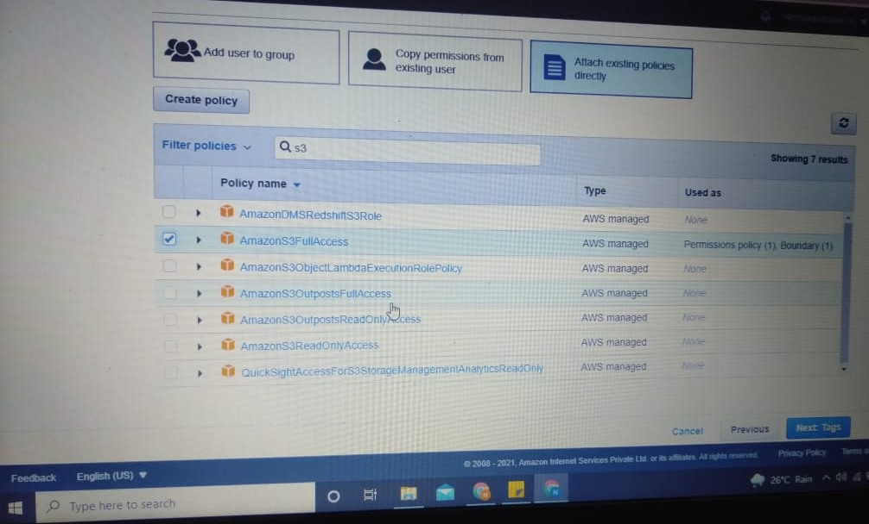

**For EC2 I am selecting policy AmazonEC2FullAccess.**

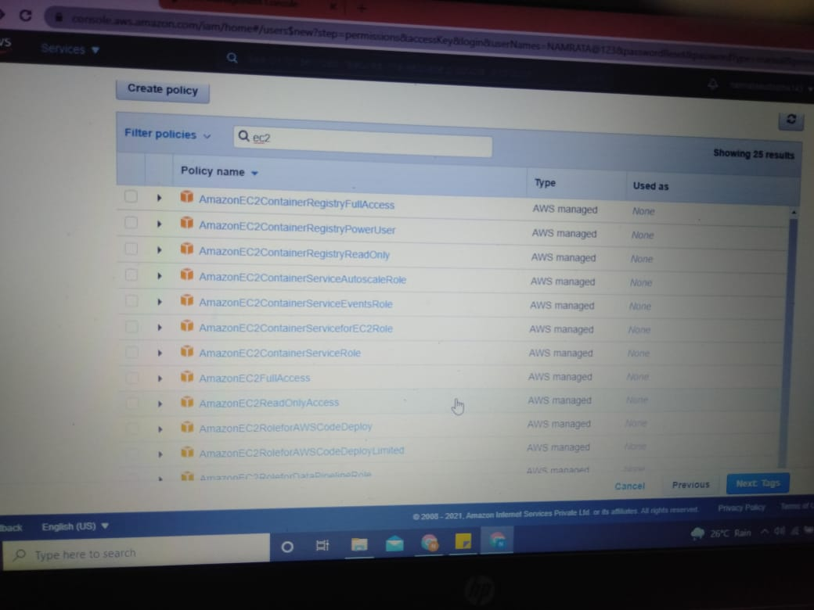

**And for IAM Access policy I am selecting IAMFullAccess.**

**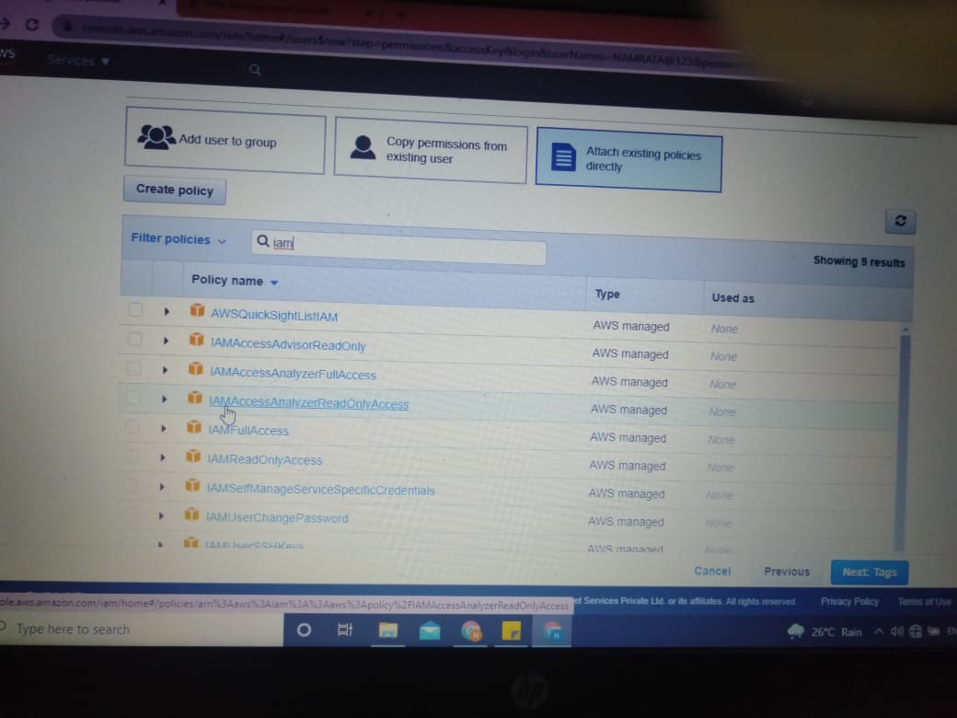**

**After Selecting 3 policies click on Next Tags.**

**You can also skip Tags option and go to next page i.e Next Review.**

Here you can see all the option selected and all the policies allowed to access the user.

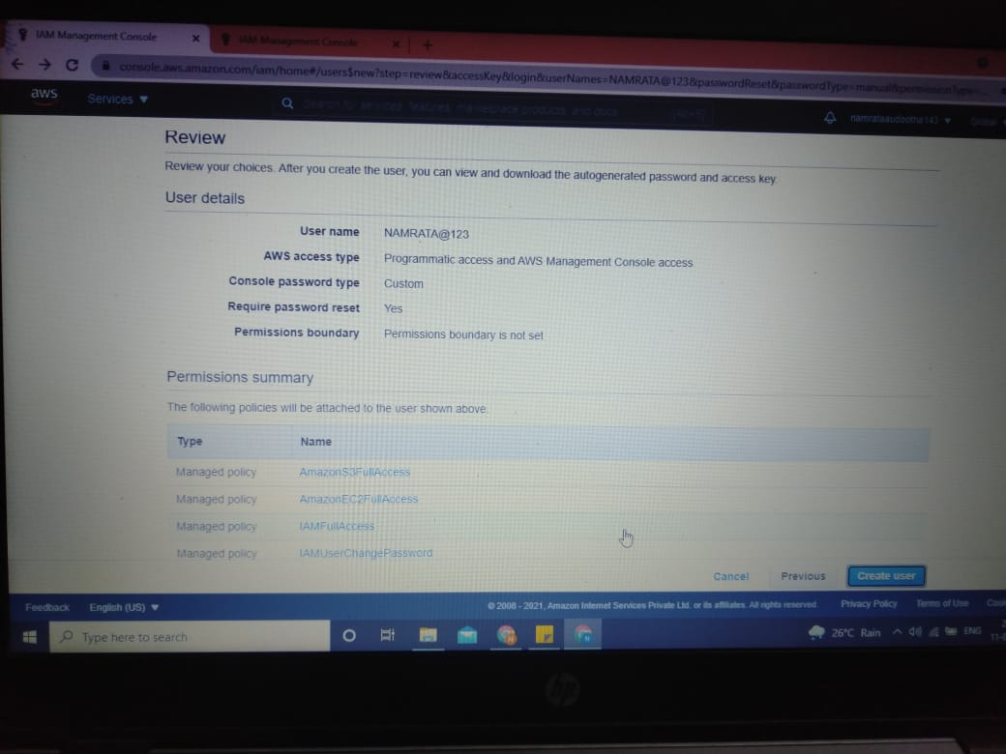

After reviewing all the details click on **Create user** bar. Here your user is created.

After clicking on Create user, the next page will be show you all the login details which can also be saved.

Please don’t forget to Download.csv file.

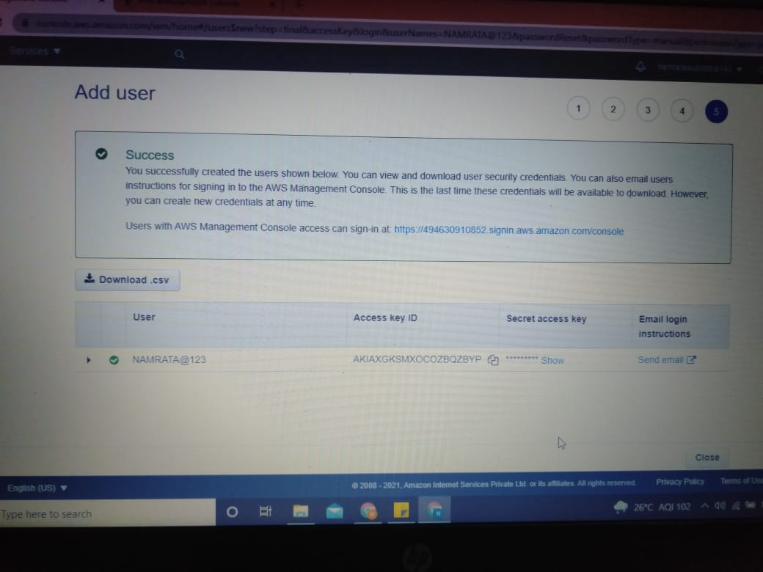

**How to Login as user and check the access to policies.**

1. Click on Sign in to Console on the screen of AWS Management Console.
2. Select IAM User to log in
3. You will be asked to enter your 12 digits Account ID, IAM user name and password.

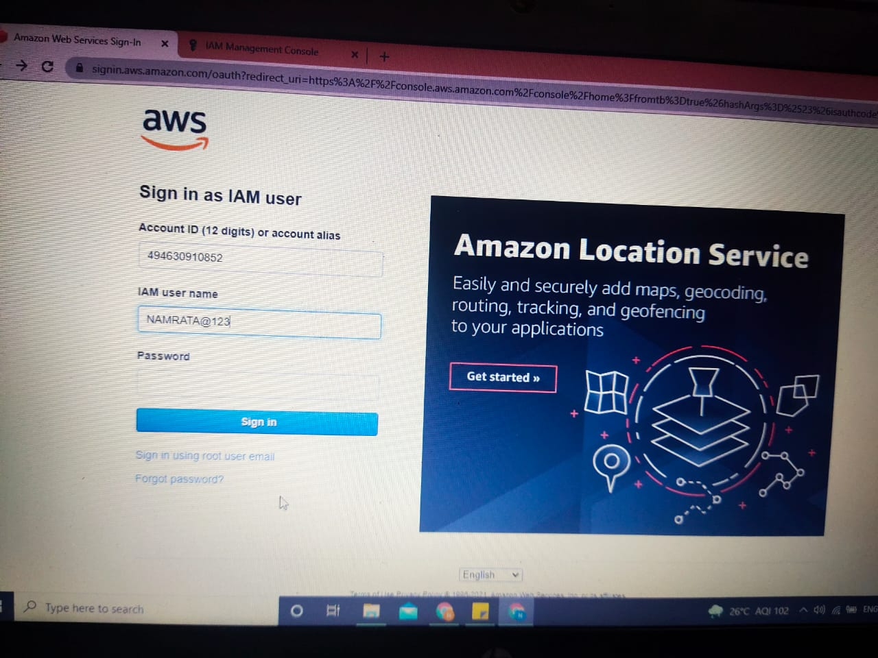

1. After entering password you will be asked to Reset your password for 1st login .

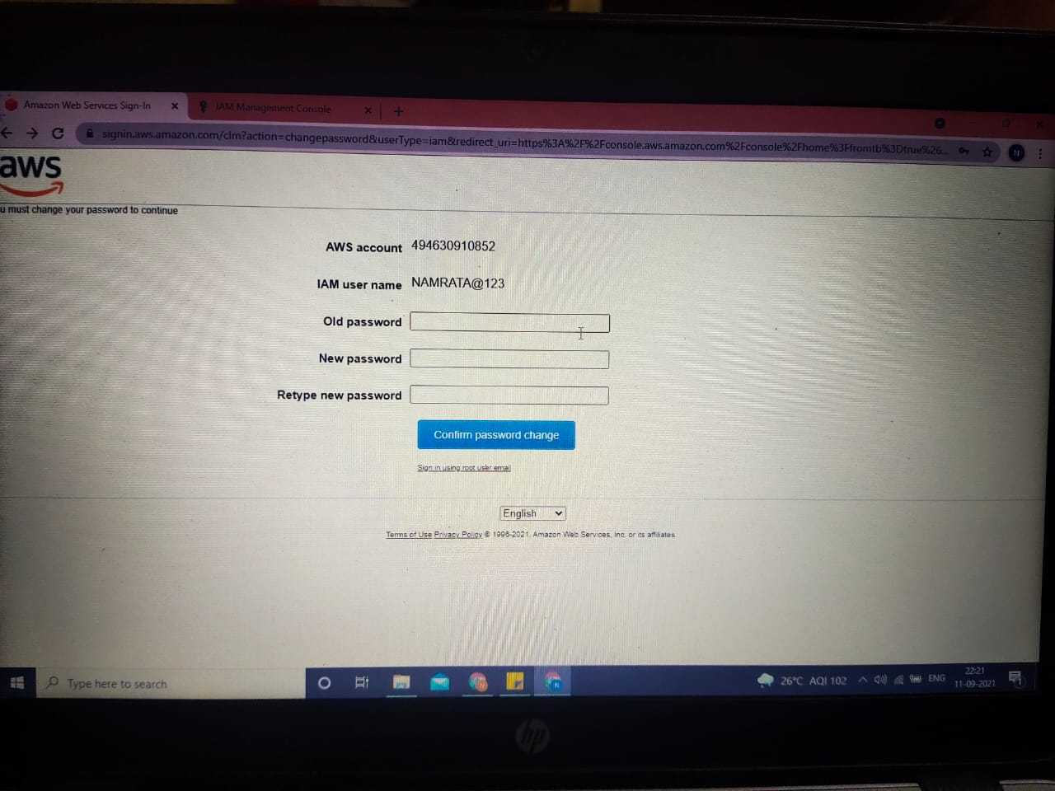

1. After changing your password you will be directed to home screen of AWS Management Console from where you can see to all the AWS services.

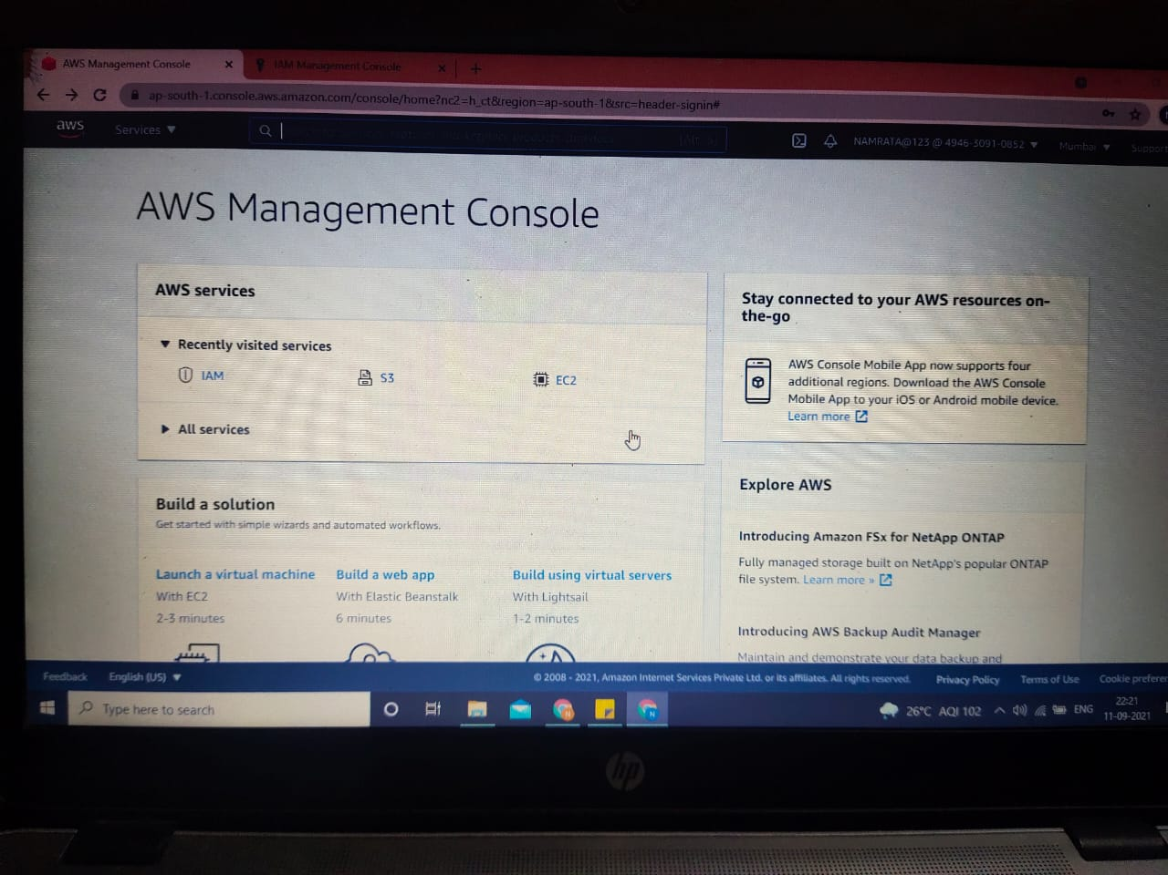

1. You can Type S3 in the search bar to check if you’re accessed to the policy. If you have been allowed to access then you will be able to create a bucket.

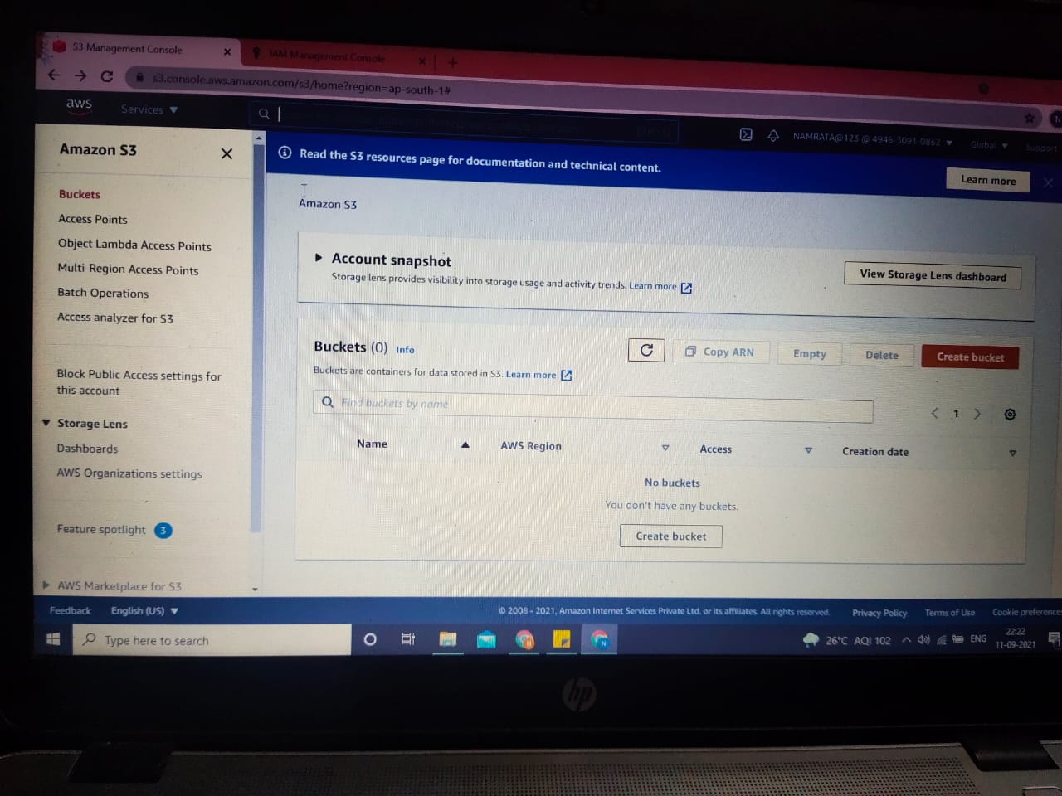

1. You can Type EC2 in the search bar to check if you’re accessed to the policy. If you are allowed to access EC2 dashboard then the screen will look like the below picture.

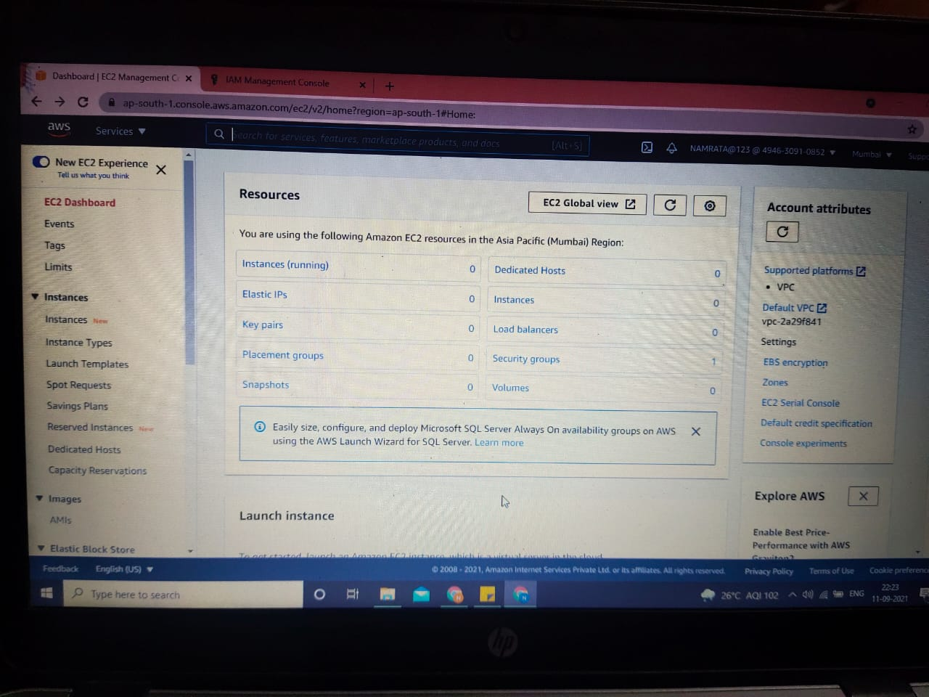

1. You can Type IAM in the search bar to check if you’re accessed to the policy. If you are allowed to access IAM then you will be able to add new user as well.

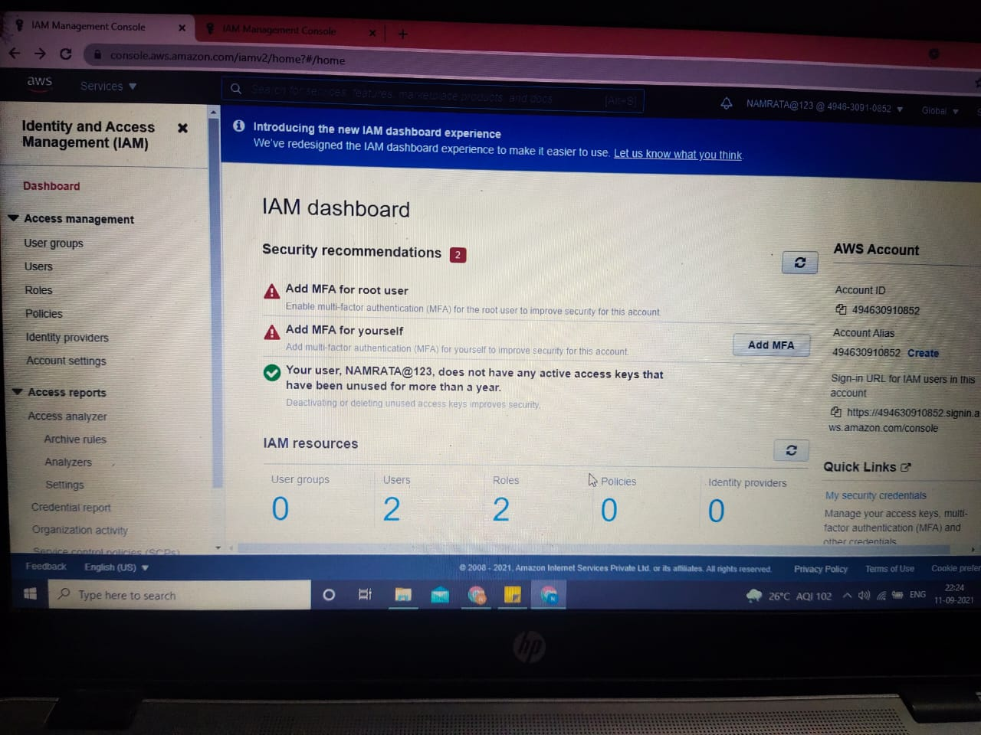

**THE END**